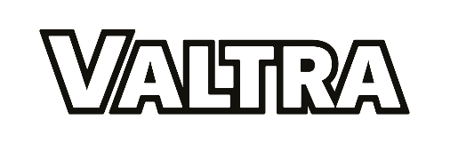
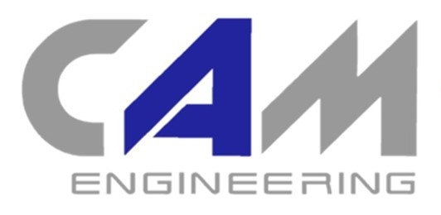
SMART CHECK

What is SMART Check?
A FREE MACHINE CHECK: Customers can receive a free and comprehensive machine check from 1st October 2022 to 31st March 2023 inclusive, on any self-propelled machine aged five years and older, to give them a ‘SMART start’ to the season. This offer excludes machines with a valid AGCO service or extended warranty contract and is subject to dealer availability.
USING EXPERT TECHNICIANS: All checks and any subsequent remedial work are undertaken by highly-trained and professionally-equipped technicians, using Genuine AGCO Parts.
PROVIDING FARMERS WITH PRE-SEASON CONFIDENCE: Farmers can benefit from AGCO’s standard 12-month parts and labour warranty for any work undertaken following the SMART Check.
ELIGIBLE MACHINES: Self-propelled machines aged five years and older, excluding any machine which has a valid AGCO service or extended warranty contract. Age of qualifying machine is counted from the registration date to 31st March 2023.

Call 07944157783 to book yours

